Psychological statistics
Homework Assignment ②
B812109041 Isaac, Lee

- SOCCER GAMES
  - Chi-square test for independence (two-variable)
    - H0: People from Sage or Sussex and Score variables are independent.
    - H1: People from Sage or Sussex and Score variables are associated.
  - Contingency table
Score/Job | Sage Publications | University of Sussex
Yes | 5 | 23
no | 19 | 30

Shooting success rate
- Sage: 20.8%
- Sussex: 43.48%

  - Chi-square Test
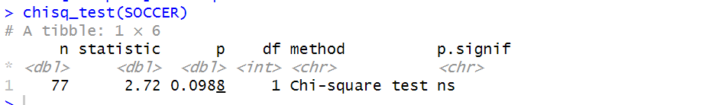
  - Conclusion
- People from Sage or Sussex and Score variables are not associated. (p = 0.0988, cannot reject H0)
- Based on the results of the chi-square test, we cannot conclude from this data that "We predict that Sussex people will score more than Sage people."

- ONE-HANDED CYCLISTS
  - Chi-square test for independence (two-variable)
    - H0: Nationality of People and the way of cycling are independent.
    - H1: Nationality of People and the way of cycling are associated.

  - Contingency table
Hand / Nationality | English | Dutch
One Handed | 17 | 120
Two Handed | 154 | 578

The proportion of cyclists riding with one hand:
- English: 9.94%
- Dutch: 17.19%
  - Chi-square Test
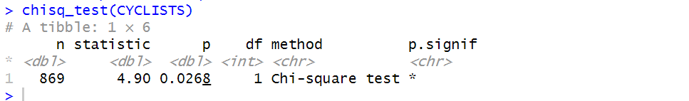
  - Conclusion
- Nationality of People and the way of cycling are not independent. (p = 0.0268, reject H0)
- Based on the results of the chi-square test, it is evident that nationality and cycling habits are correlated variables. Therefore, it is possible to determine from the contingency table data whether it is the English or the Dutch who are more likely to ride bicycles with one hand.
- English (9.94%) < Dutch (17.19%), Dutch people have a higher proportion of cycling with one hand.

- DARK LOAD
- What is the hypothesis to be tested?
Whether "backward masked messages" have a significant difference in their impact on butchers.

- Analyze the data with a Wilcoxon signed-rank test and report the effect size.
  - Set up Hypothesis.
- H0: The impact of "backward masked messages" on butchers has not shown a significant difference.
- H1: The impact of "backward masked messages" on butchers has shown a significant difference.

  - Repeated-measure Wilcoxon test 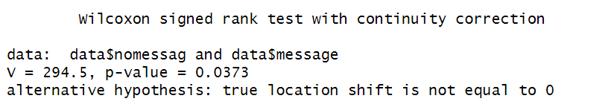
  - Effect size.
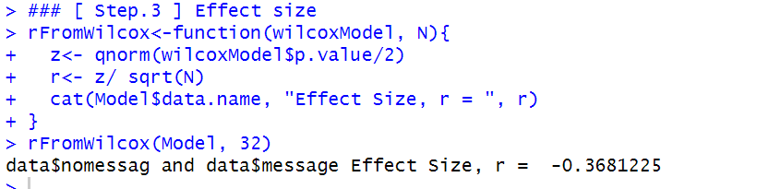
  - Conclusion
- According to the Wilcoxon signed-rank test, with a p-value of 0.0373 < 0.05, we can reject the null hypothesis (H0). This indicates that there is a significant difference in the impact of "backward masked messages".

- Would the results be different using t-test?
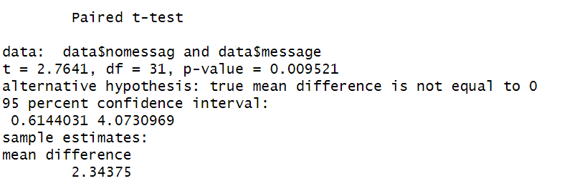
- The p-value of the t-test is 0.009521, which is significantly smaller than that of the Wilcoxon signed-rank test (p = 0.0373).

- CHECK THE PAPER
- Please identify the statements of research question, hypothesis, and statistic testing methods.
- Research Question: The purpose of this study was to identify cortical and subcortical substrates related to respiratory sensory gating elicited by paired inspiratory occlusions.
- Hypothesis: The ratio of effect size in the paired- versus single-occlusion condition (β paired /β single) would be less than 2.
- Statistic Testing Methods: Wilcoxon Signed - Rank test.

- Please reproduce the results using the attached dataset in R. Report your own decision following the testing.
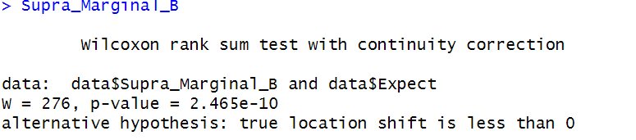

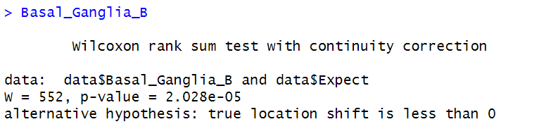
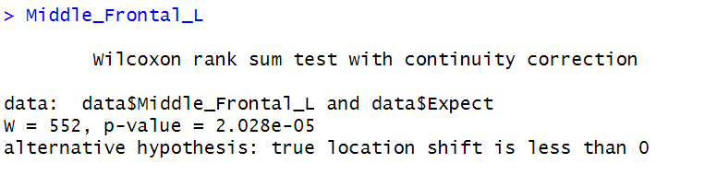
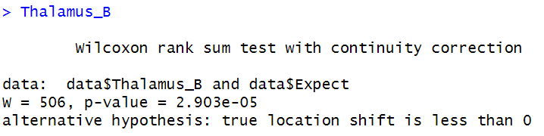
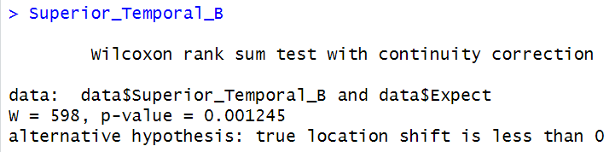
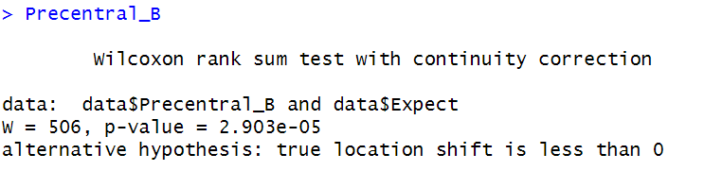
Conclusion
According to the Wilcoxon signed-rank test, all p-values of the results are far less than 0.05. Therefore, it can be concluded that a beta ratio less than 2 exhibits a significant difference.

